

# Perth Modern School

### Semester Two Examination, 2018

### Question/Answer Booklet

# MATHEMATICS

**METHODS**

**UNIT 3 and 4**

## Section One:

## Calculator-free

Student’s name

Your Teacher’s name

## Time allowed for this section

Reading time before commencing work: five minutes

Working time for section: fifty minutes

## Materials required/recommended for this section

***To be provided by the supervisor***

This Question/Answer Booklet

Formula Sheet

***To be provided by the candidate***

Standard items: pens (blue/black preferred), pencils (including coloured), sharpener, correction fluid/tape, eraser, ruler, highlighters

Special items: nil

## Important note to candidates

No other items may be taken into the examination room. It is **your** responsibility to ensure that you do not have any unauthorised notes or other items of a non-personal nature in the examination room. If you have any unauthorised material with you, hand it to the supervisor **before** reading any further.

|  |  |  |  |
| --- | --- | --- | --- |
| Question | Marks awarded | Question | Marks awarded |
| 1 |  | 5 |  |
| 2 |  | 6 |  |
| 3 |  | 7 |  |
| 4 |  |  |  |

## Structure of this paper

|  |  |  |  |  |  |
| --- | --- | --- | --- | --- | --- |
| Section | Number of questions available | Number of questions to be answered | Working  time (minutes) | Marks available | Percentage of exam |
| Section One:  Calculator-free | 7 | 7 | 50 | 50 | 35 |
| Section Two:  Calculator-assumed | 13 | 13 | 100 | 103 | 65 |
|  | | | **Total** | 153 | 100 |

## Instructions to candidates

1. The rules for the conduct of examinations are detailed in the school handbook. Sitting this examination implies that you agree to abide by these rules.
2. Write your answers in this Question/Answer Booklet.
3. You must be careful to confine your response to the specific question asked and to follow any instructions that are specified to a particular question.
4. Spare pages are included at the end of this booklet. They can be used for planning your responses and/or as additional space if required to continue an answer.

* Planning: If you use the spare pages for planning, indicate this clearly at the top of the page.
* Continuing an answer: If you need to use the space to continue an answer, indicate in the original answer space where the answer is continued, i.e. give the page number. Fill in the number of the question that you are continuing to answer at the top of the page.

1. **Show all your working clearly**. Your working should be in sufficient detail to allow your answers to be checked readily and for marks to be awarded for reasoning. Incorrect answers given without supporting reasoning cannot be allocated any marks. For any question or part question worth more than two marks, valid working or justification is required to receive full marks. If you repeat any question, ensure that you cancel the answer you do not wish to have marked.
2. It is recommended that you **do not use pencil**, except in diagrams.
3. The Formula Sheet is **not** to be handed in with your Question/Answer Booklet.

Section One: Calculator-free 35% (50 Marks)

This section has**seven (7)** questions. Answer **all** questions. Write your answers in the spaces provided.

Working time for this section is 50 minutes.

Question 1 (6 marks)

Determine the derivative for each of the following, ensuring all answers are

expressed with positive indices.

a) $f\left(x\right)=3x^{5}-\frac{2}{x^{3}}$ [2]

b) $g\left(x\right)=\frac{2x^{2}}{{\left(3-2x\right)}^{3}}$ (Do not simplify) [2]

c) $h\left(x\right)=\sqrt[4]{x^{3}}- \sqrt[3]{x^{4}}$ [2]

Question 2 (8 marks)

(a) Anne got 90% for her Literature exam. The class average was 80% and the standard deviation was 5. John got 80% in the Methods exam. His class average was 70% and the standard deviation was 4.

Who did relatively better in their exam, Anne or John? (3)

(b) Jane rode her motorbike to work every day, going through two sets of traffic

lights.

Let  be the probability density function that gives the probability of the

number of red lights Jane encounters in one day.

|  |  |  |  |
| --- | --- | --- | --- |
| *x* | 0 | 1 | 2 |
| *P*(*X = x*) | 0.5 | 0.3 | 0.2 |

(i) Determine the expected number of red lights per trip. (2)

(ii) What is the probability that Jane had 2 red lights two days in a row? (1)

(iii) Determine the standard deviation of the distribution of.

Leave your answer un-simplified. (2)

Question 3 (8 marks)

The function  is graphed on the axes below.

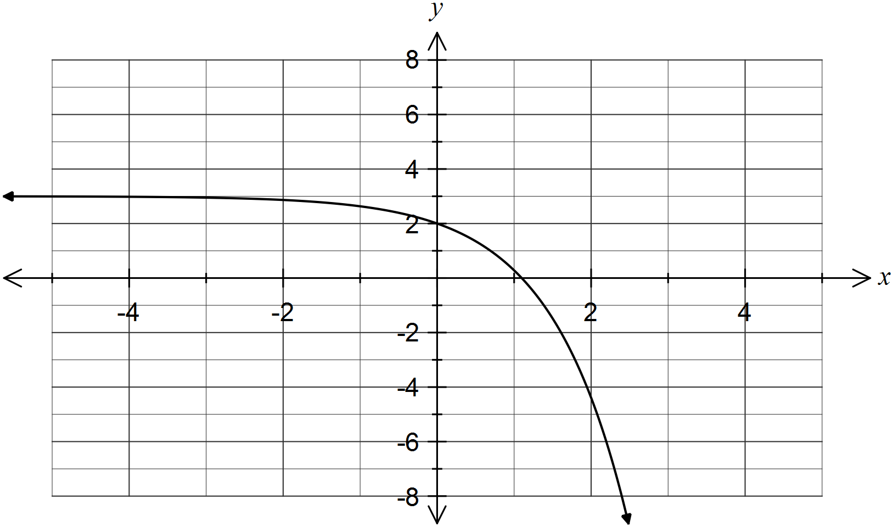

(a) If ,  and , evaluate each of the following definite integrals in terms of the constants a, b and c.

(i) . (1 mark)

(ii) . (2 marks)

(iii) . (2 marks)

(b) On the axes above, sketch the graph of , showing all relevant features.

(3 marks)

Question 4 (5 marks)

(a) Determine $\int{\sqrt{x}-\frac{1}{x^{2}}}dx$ (2 marks)

(b) If  and , determine . (3 marks)

Question 5 (7 marks)

(a) Two hundred and fifty randomly selected students were surveyed to determine if

an overseas trip for students should be planned for students in Year 10, or in

Year 11 or in Year 12.

The results are in the table below.

|  |  |  |  |
| --- | --- | --- | --- |
| Year | 10 | 11 | 12 |
| Preference | 90 | 90 | 70 |

(i) Convert the data to form a probability density function. (2)

|  |  |  |  |
| --- | --- | --- | --- |
|  | 10 | 11 | 12 |
|  |  |  |  |

(ii) If two students from the school were selected at random, what is the

probability that they both thought Year 12 students should not go on an

overseas trip. (Do not simplify) (2)

(b) Which of the following represents a probability density function?

Give your reasons. (3)

(i)

|  |  |  |  |  |
| --- | --- | --- | --- | --- |
| *x* | 0 | 1 | 2 | 3 |
| *P*(*X = x*) | 0.1 | 0.2 | 0.3 | 0.4 |

(ii)

|  |  |  |  |  |
| --- | --- | --- | --- | --- |
| *x* | 10 | 11 | 12 | 13 |
| *P*(*X = x*) | 0.2 | 0.3 | 0.1 | 0.5 |

(iii)

|  |  |  |  |  |
| --- | --- | --- | --- | --- |
| *x* | 6 | 7 | 8 | 9 |
| *P*(*X = x*) | 0.4 | 0.5 | -0.3 | 0.4 |

Question 6 (6 marks)

(a) Find the area between the function and theaxis. (3)

(b) Write down the expression for the area between the functions  between $-π≤x≤ π$

that is illustrated in the diagram below. (3)

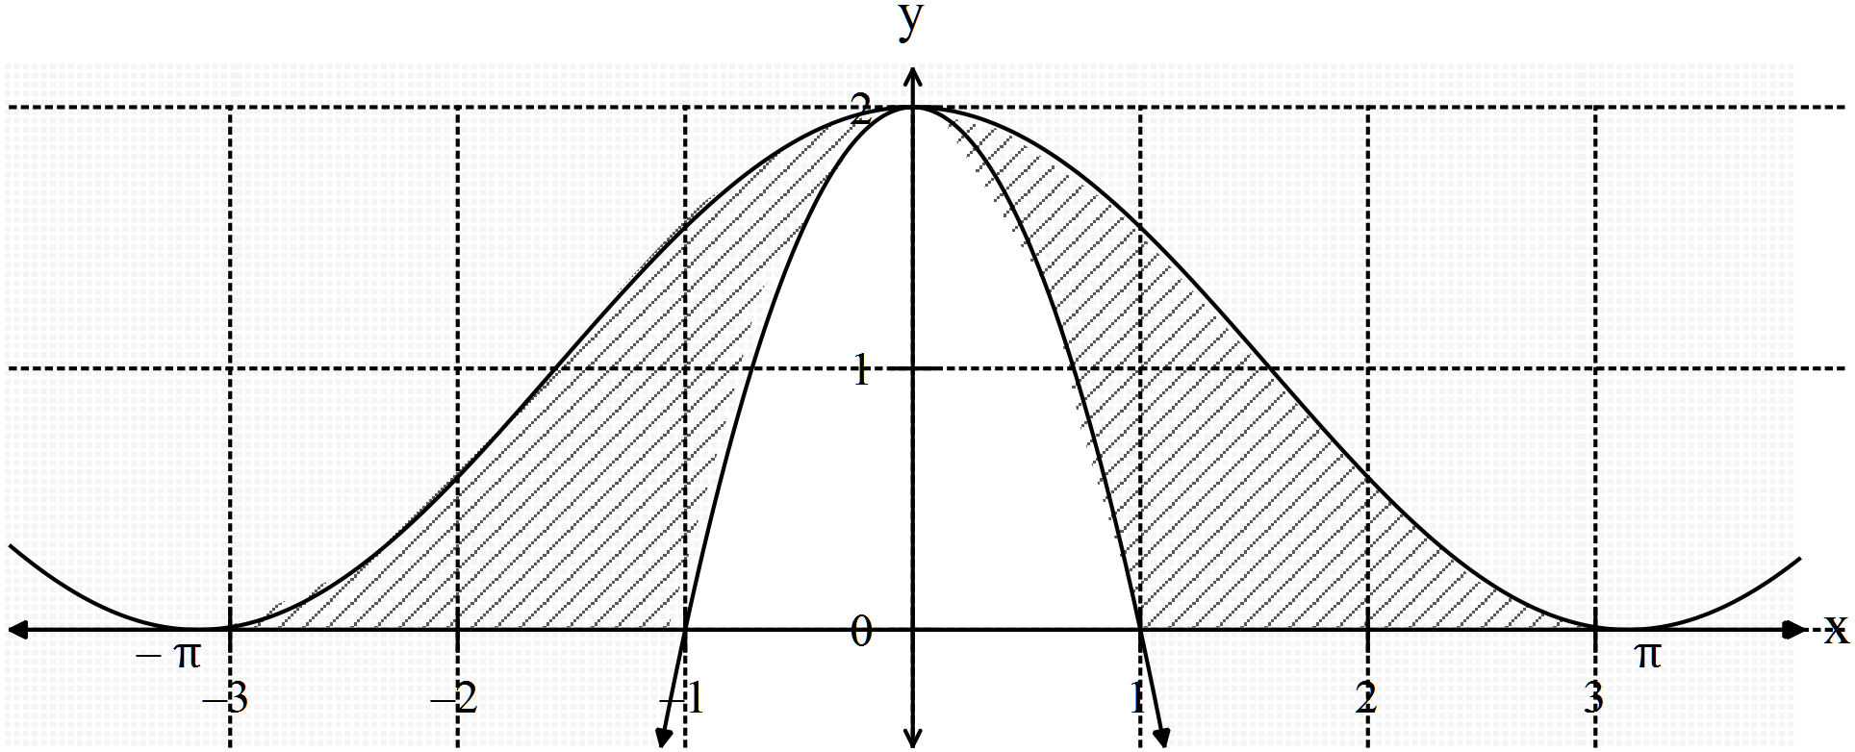

Question 7 (10 marks)

The height of a piston is given by $h\left(t\right)=3\cos\left(t\right)+3$ where  is measured in

metres and  in seconds.

(a) Sketch the height of the piston on the set of axes below for  (2)

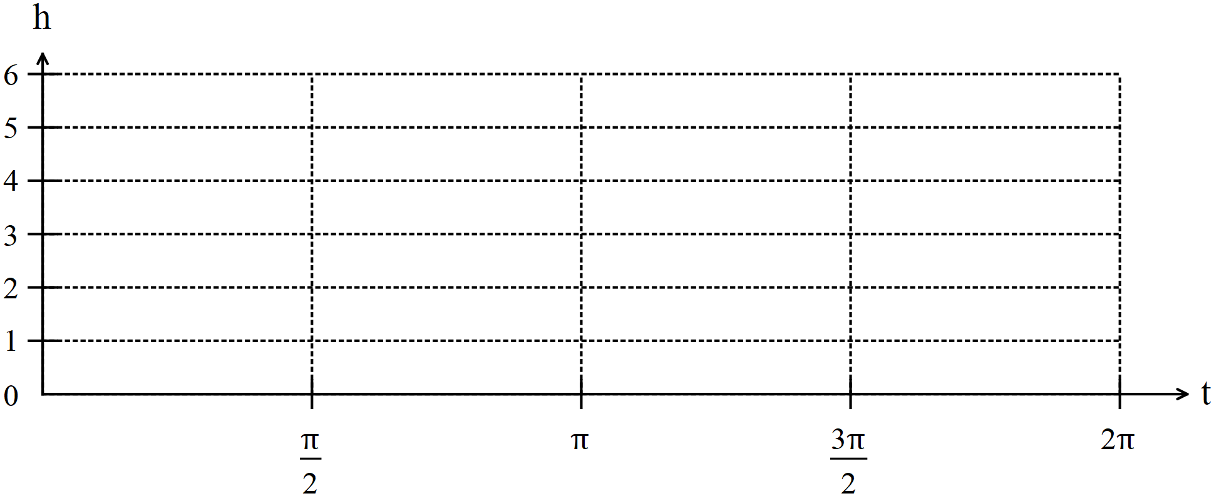

(b) At what rate is the piston rising at ? (2)

(c) Explain using the graph in (a) why your answer to (b) gives the maximum

rate of rise of the piston. (3)

(d) At what rate is the velocity of the piston changing at ? (3)

Additional working space

Question number: _________

Additional working space

Question number: _________

Additional working space

Question number: _________